Assignment 4

Prabhuram S S

1.Pull an Image from docker hub and run it in docker playground.

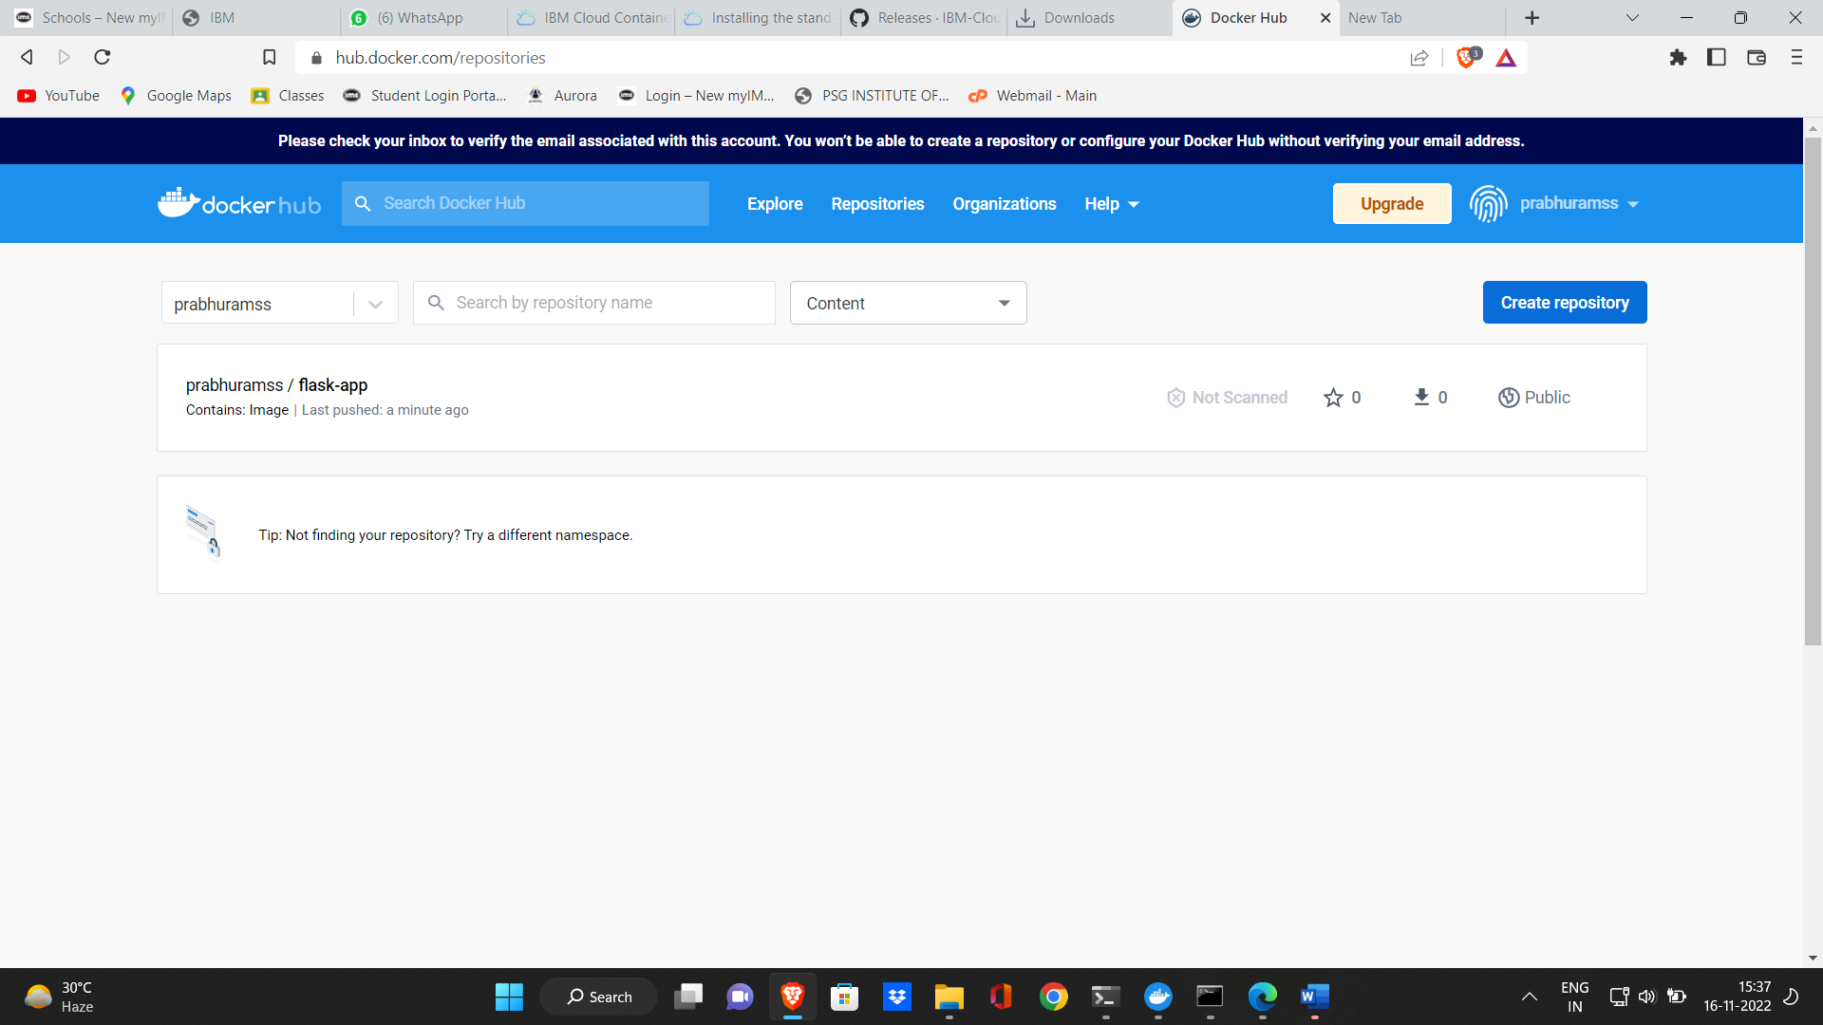

2.Create a docker file for the jobportal application and deploy it in Docker desktop application.

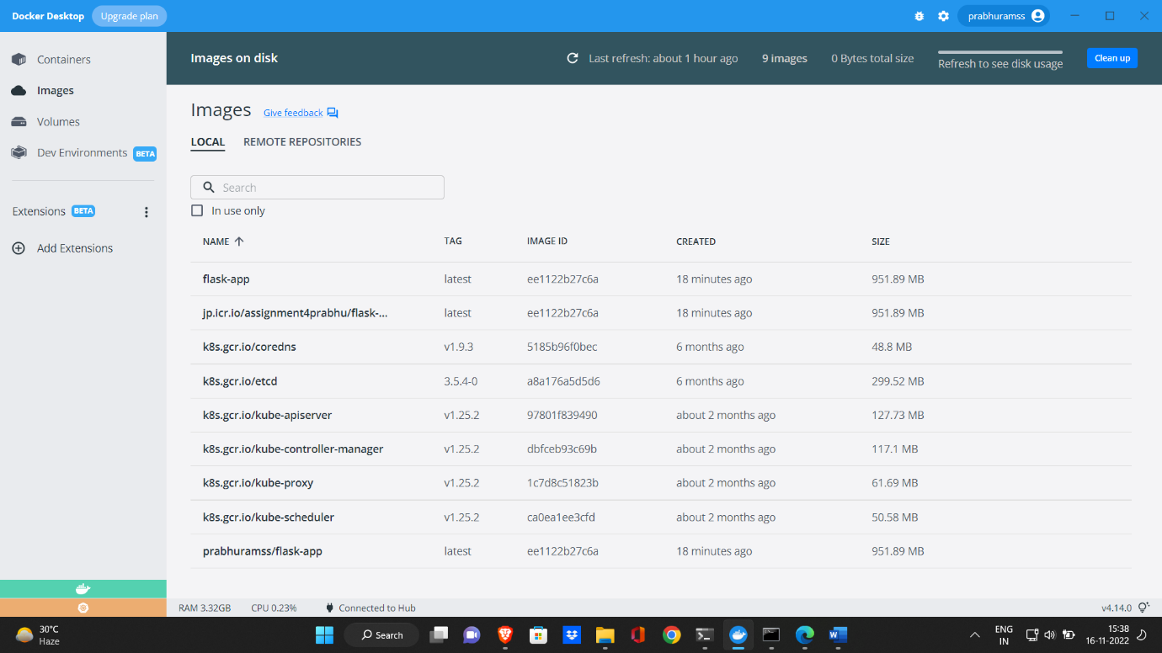

3.Create a IBM container registry and deploy helloworld app or jobportalapp.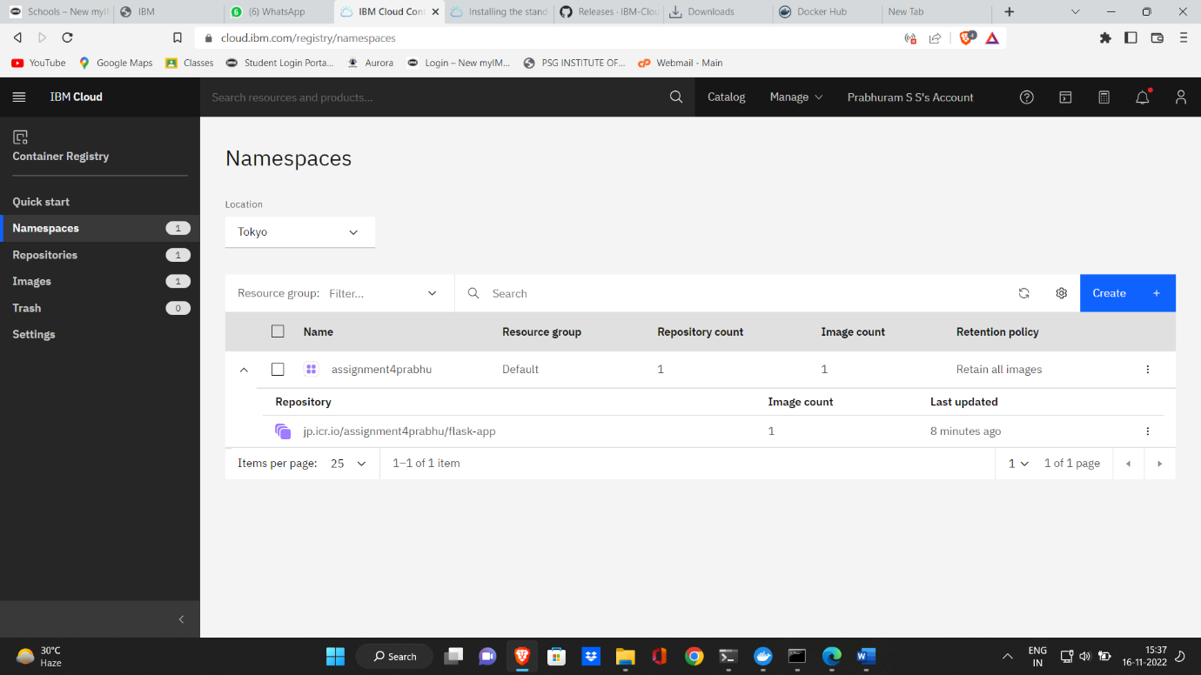

4.Create a Kubernetes cluster in IBM cloud and deploy helloworld image or jobportal image and also expose the same app to run in nodeport.

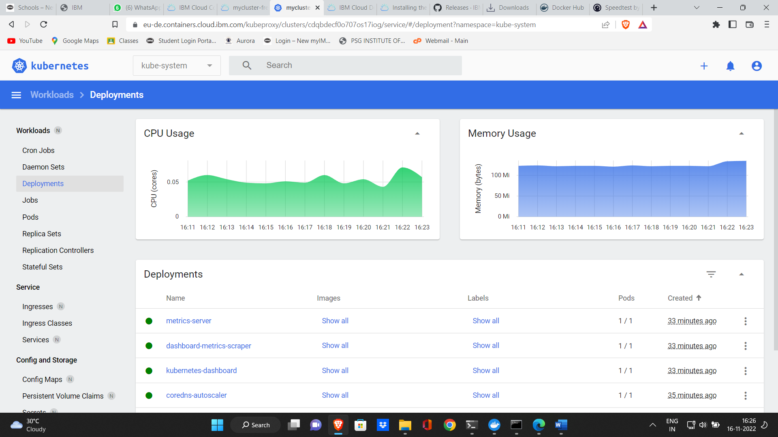

A